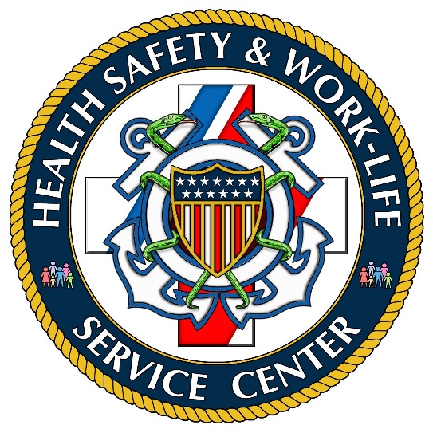

Regional Behavioral Health Provider Locations

CDR Vanessa Goosen Seattle, WA
CDR Sherry Gracey Honolulu, HI
CAPT Robin Lewis Charleston, SC
CDR Gina Ligonde Cleveland, OH
CDR Marlene Nicholson Miami Beach, FL
CAPT Amy Park Long Beach, CA
CDR Kymberly Spady-Grove New Orleans, LA

To contact a member of your behavioral health team please send an email to
Behavioralhealth@uscg.mil

